Annual Report of “Development Action Plan for Scheduled Caste (DAPSC) (formerly SCSP) 2022”

A central government sponsored and funded scheme, “Development Action Plan for Scheduled Caste (DAPSC) (formerly Scheduled Caste Sub Plan SCSP)” was implemented by the ICAR-CICR, Nagpur. The main objective of this plan is to emphasize the developmental programmes for the Scheduled Castes, in relation to their agribusiness pattern and the need to increase productivity and income from their limited resources. The objective of the scheme was to increase the income levels of the targeted population through various income generating schemes, skill development and infrastructure development. The scheme was implemented in the selected PMAGY and other Non- PMAGY villages in Five Districts of Maharashtra namely Nagpur, Wardha, Chandrapur, Amaravati and Bhandara where the Scheduled Caste population is 50% or more by identifying the beneficiary families with the help of State Government Agencies. The program planning was done at the institute level and executed by the committee members in the adopted villages. The poor families were targeted to directly use the various agricultural related inputs provided by the Institute. The scientific inputs in terms of technology dissemination, technological interventions, capacity building, showcasing technologies, exposure visits, interface meetings and trainings, skill up gradation, timely solutions of the farmers problems, cleanliness of public premises, sanitization and providing information of various schemes implemented by state agricultural departments.
Various activities were carried out in the adopted villages to provide direct benefit to the scheduled caste beneficiaries under the SCSP Scheme. These includes, organization of skill development programmes, trainings and workshops, distribution of Goat & Goat Feed, improved Cotton cultivation practices, Paddy seed, Red Gram seed, Soyabean seed, Gram seed (Chickpea), Wheat seed, Crop protection Kit (Pesticide Kit), Pusa bio-fertilizer kit, Tarpaulin, Vermicompost bed, Vegetable plant based kit, Citrus plant based kit, Sickle, Pesticide Protection Kit, Pheromone Traps & lure, Cotton picking bags and printed cotton cultivation practices. The farmers were sensitized on round the year for Cotton production and its scientific cultivation, with complete package of practices and seeds. The programme was implemented with involvement of the following team members of SCSP committee constituted by the authority.

Nodal Officer: Dr. J. H. Meshram, Principal Scientist (Plant Physiology)
Members: Dr. Ramkrushna G. I., Sr. Scientist (Agronomy)
Dr. S. P. Gawande, Sr. Scientist (Plant Pathology),
Dr. B. B. Fand, Sr.Scientist (Entomology),
Dr. N. S. Hiremani, Scientist (Plant Pathology),
Dr. U.V. Galkate, SMS (Veterinary Sciences), KVK,
Shri. Akshay Kamble, Technician,
Shri. Akshay Barahate, Technician,
Shri. Eluka Shridhar, Technician,
CAO & FACO

Details of various Training programme carried out under SCSP Scheme.

Sr.  No. | Details of Training Programmes | Date | Venue | No of SC beneficiaries
1. | Training cum Demonstration of Cotton Stalk Shredder on Cotton field to SC farmers. | 02 March 2022. | ICAR - CICR, Nagpur. | 50
2. | Training program on Scientific Goat Farming & livestock management for SC beneficiaries. | 29 March 2022 | Punyashlok Ahilyadevi Maharashtra Mendhi va Sheli Vikas Prakshetra, Bondri, Ta. Ramtek, Dist. Nagpur. | 50
3. | Stakeholders Interface Farmers Meeting for Pre-Kharif season  (Interface Farmers Meeting cum Training for Pre-Kharif season to increase Cotton Production using better cultivation and improved technologies.) | 07 May 2022 | VANAMATI, Nagpur | 40
4. | Training program on ‘Improved Cotton Production Technology’ on the occasion of “Garib Kalyan Sammelan”. | 31 May 2022 | ICAR - CICR, Nagpur. | 482
5. | Training program on ‘Scientific Soybean Cultivation’ to SC farmers. | 14 June 2022 | KVK, ICAR- CICR, Nagpur. | 57
6. | Training on Tur Cultivation | 15 June 2022 | Welsakhara, Godhani and Dhurkheda Ta. Umred, Dist. Nagpur. | 157
7. | Training program on ‘Scientific Soybean Cultivation’ to SC farmers | 17 June 2022 | KVK, VNMKV, Aurangabad. | 64
8. | Training program on Kharif crop (Paddy and Tur) Cultivation to SC farmers. | 20 June 2022 | Khobna, Bodakhipeth, Sawarkhanda Amti Ta. Kuhi, Dist. Nagpur. | 113
9. | Training on usages of PUSA Bio-fertilizers for SC farmers of Nagpur district. | 17 August 2022 | Welsakhara, Godhani, Pipardol, Amboli, Ta. Umred Dist. Nagpur | 234
9. |  | 23 August 2022 | Khobna and Bodakhipeth  Ta. Kuhi, Dist. Nagpur | 234
10. | Training on Integrated pest Management and Cotton field visit to SC farmers at MGMG village. | 08 September 2022 | Dongargaon, Ta. Kuhi, Dist. Nagpur. | 26
11. | Training on ‘Integrated Cotton management’ on the occasion of "World Cotton Day" | 07 October 2022 | ICAR - CICR, Nagpur. | 85
12. | Training on Integrated pest Management and Cotton field visit to SC farmers at MGMG villages. | 12 October 2022 | Venue: ICAR – KVK, Hans Roever campus, Vaalikandapuram, Perambalur, Beneficiary village: Tharani in Parambalur District, Tamil Nadu) | 50
13. | Farmers training on Cotton cultivation cum exposure visit at CICR Cotton fields on the occasion of “PM KISAN SAMMAN SAMMELAN” | 17 October 2022 | ICAR - CICR, Nagpur. | 132
14. | Farmers Training on PBW management in cotton field and usages of Pheromone Trap. | 02 November 2022 | Wadegaon, Pipardol, Ta. Umred, Dist. Nagpur. | 74
15. | Training programme on “Integrated Cotton Cultivation”, Exposure visit and Exhibition on the occasion of “Kapas Mela 2022” | 24 November 2022 | ICAR - CICR, Nagpur. | 400
16. | Workshop and Training on “Soil Health Management” on the occasion of “World Soil Day -2022” | 05 December 2022 | ICAR - CICR, Nagpur. | 45

Details of Critical input distributed under SCSP Scheme.

Sr. No. | Details of Input | Date | Venue / Beneficiary Village | No of SC beneficiaries
1. | Tarpaulin  (Standard size Tarpaulins to protect the crop/seed from rain.) | 02 March 2022 | Venue : ICAR-CICR, Nagpur  Beneficiary Village : Bodakhipeth, Khobna, Sonapar, Pipardol Amboli, Tirkhura | 435
1. |  | 17 October 2022 | Venue : ICAR-CICR, Nagpur  Beneficiary Village :  Chikhali Maina, Wadvihara, Khadaki, Parsodi, Khairi Punjab, | 435
1. |  | 20 October 2022 | Durgada | 435
1. |  | 28 October 2022 | Amboli, Tirkhura, Welsakhara | 435
1. |  | 02 November 2022 | Pipardol | 435
1. |  | 09 November 2022 | Chikhali Maina | 435
2. | Sickle  (Distributed 2 Sickle to each SC beneficiary.) | 02 March 2022 | Venue : ICAR-CICR, Nagpur  Beneficiary Village :  Bodakhipeth, Khobna, Pipardol, Amboli, Tirkhura, Sonapar | 283
2. | Sickle  (Distributed 2 Sickle to each SC beneficiary.) | 28 October 2022 | Welsakhara | 283
2. | Sickle  (Distributed 2 Sickle to each SC beneficiary.) | 01 November 2022 | Khapri | 283
2. | Sickle  (Distributed 2 Sickle to each SC beneficiary.) | 09 November 2022 | Khairi Punjab, Chikhali Maina | 283
2. | Sickle  (Distributed 2 Sickle to each SC beneficiary.) | 27 December 2022 | Mendhepathar, Palwadi | 283
3. | Female Goat  (Vaccinated Two female goats & 50 Kg Goat Feed distributed to each Scheduled caste Beneficiary from Nagpur district.) | 29 March 2022 | Venue: Punyashlok Ahilyadevi Maharashtra Mendhi va Sheli Vikas Prakshetra, Bondri, Ta. Ramtek, Dist. Nagpur.  Beneficiary Villages: Kinhi Khurd, Khapri, Wakeshwar, Welsakhara | 50
4. | Crop Protection Kit  (containing Fungicides, Insecticides and Bio-Fertilizers namely Neem Oil ,Nano Urea,  Liquid Consortia (NPK), Flonicamid,  Chlorantraniliprole, Propiconazole, Metiram & Pyraclostrobin, Tricoderma, Poweder, Boron Fertilizer, Zinc Fertilizer) | 31 May 2022 | Venue : ICAR-CICR, Nagpur  Beneficiary Village : Welsakhara, Godhani, Dhurkheda, Amboli, Wadegaon, Pipardol, Thombra, Tirkhura, Pavani, Sillori, Sonapar, Amti, Khobna, Bodakhipeth, Sawarkhanada, Khapari, Durgada | 784
4. |  | 22 June 2022 | Pavani | 784
4. |  | 08 September 2022 | Dongargaon, | 784
4. |  | 07 October 2022 | Venue : ICAR-CICR, Nagpur  Beneficiary Village :  Waadvihara, Khadki, Parsodi, Khairi Punjab, Chikhali Maina, Hingna | 784
4. |  | 09 November 2022 | Khairi Punjab, Chikhali Maina | 784
4. |  | 10 November 2022 | Waadvihara | 784
4. |  | 05 December 2022 | Venue : ICAR-CICR, Nagpur  Beneficiary Village :  Khadki, Parsodi | 784
4. |  | 27 December 2022 | Mendhepathar, Palwadi | 784
5. | Soybean  (Soybean JS-2069 for front line demonstration (FLDs) On 57 acres of farmer’s field in Nagpur district.) | 14 June 2022 | Venue: KVK, ICAR- CICR, Nagpur.  Farmers from Kamptee, Kuhi, Mauda, Nagpur, Narkhed and Umred Taluka, district Nagpur. | 57
6. | Soybean  (Soybean (NRC-130) for front line demonstration (FLDs). On 64 acres of farmer’s field in Aurangabad district.) | 17 June 2022 | KVK, VNMKV, Aurangabad. | 64
7. | Tur Seed  (Variety PKV – TARA having 2 kg packing (4 Kg to each) distributed for Cotton intercropping to Scheduled caste farmers for Kharif season.) | 15 June 2022 | Welsakhara, Godhani, Dhurkheda | 871
7. |  | 16 June 2022 | Amboli, Wadegaon, Pipardol, Thombara, Tirkhura | 871
7. |  | 17 June 2022 | Sillori, Sonapar | 871
7. |  | 18 June 2022 | Durgada, Tekari, Dhamangaon Chak | 871
7. |  | 20 June 2022 | Amti, Khobna, Bodakhipeth, Kuhi, Sawarkhanda | 871
7. |  | 22 June 2022 | Pavani | 871
7. |  | 24 June 2022 | Dawadipar Bazar | 871
8. | Paddy  (PDKV–Tilak variety of Paddy distributed to Scheduled caste farmers for Kharif season.) | 16 June 2022 | Tirkhura | 200
8. |  | 18 June 2022 | Dhamangaon Chak, Tekari | 200
8. |  | 20 June 2022 | Khobna, Bodakhipeth | 200
8. |  | 24 June 2022 | Dawadipar Bazar | 200
9. | PUSA Bio-Fertilizer  (Bio-Fertilizer kit having powder based and liquid based fertilizers namely  Bio Azatobacter Powder  Rhizobium Powder  Biophas Powder  Biopotash Powder  Biozinc Powder  Bioiron Powder  Mycorhiza Powder  Azatobacter Liquid  Biophos Liquid  Biopotash Liquid  Biozinc Liquid  Bio-iron Liquid  Smpoorn Liquid) | 17 August 2022 | Amboli, Godhani, Pipardol, Welsakhara | 241
9. |  | 23 August 2022 | Khobna, Bodakhipeth | 241
10. | Pesticide Protection Kit  (Pesticide protection kits including Safety jackets, goggle, hand gloves, face mask, gum boots, safety helmet etc. Useful for safe handling of pesticides in agriculture field.) | 29 August 2022 | Wadvihara | 215
10. |  | 30 August 2022 | Khadki | 215
10. |  | 15 September 2022 | Parsodi, Khairi Punjab | 215
10. |  | 17 September 2022 | Chikhali Maina | 215
10. |  | 09 November 2022 | Khairi Punjab,  Chikhali Maina | 215
10. |  | 27 December 2022 | Mendhepathar, Palwadi | 215
10. |  | 27 December 2022 | Rampuri | 215
11. | Cotton Picking Bag  (KVK-CICR innovated Cotton Picking bag distributed among SC beneficiary.  Useful in clean and easy way of cotton picking.) | 15 September 2022 | Parsodi, Khairi Punjab | 302
11. |  | 17 September 2022 | Chikhali Maina | 302
11. |  | 07 October 2022 | Venue : ICAR-CICR, Nagpur  Beneficiary Village :  Parsodi, Hingna,  Wadvihara, Khadki, | 302
11. |  | 09 November 2022 | Khairi Punjab,  Chikhali Maina | 302
11. |  | 10 November 2022 | Wadvihara | 302
11. |  | 05 December 2022 | Venue : ICAR-CICR, Nagpur  Beneficiary Village :  Parsodi, Khadki | 302
11. |  | 27 December 2022 | Mendhepathar, Palwadi | 302
11. |  | 28 December 2022 | Rampuri | 302
12. | Gram Seed (Chickpea)  (Gram seed Variety, Jaki-9218 having packing 30 Kg bag. one bag to each farmer distributed to Scheduled caste farmers for Rabi season.) | 17 October 2022 | Venue : ICAR-CICR, Nagpur  Beneficiary Village :  Wadvihara, Khadaki, Parsodi, Khairi Punjab, | 500
12. |  | 19 October 2022 | Amti, Khobna, Bodakhipeth, Sawarkhanda, | 500
12. |  | 20 October 2022 | Durgada. | 500
12. |  | 21 October 2022 | Tekari | 500
12. |  | 28 October 2022 | Amboli, Welsakhara, Godhani, Tirkhura | 500
12. |  | 01 November 2022 | Khapari | 500
12. |  | 02 November 2022 | Wadegaon, Pipardol | 500
12. |  | 09 November 2022 | Chikhali Maina | 500
13. | Wheat Seed  (Wheat variety Phule Samadhan having packing 40 Kg bag. one bag to each farmer distributed to Scheduled caste farmers for Rabi season.) | 17 October 2022 | Venue : ICAR-CICR, Nagpur  Beneficiary Village :  Wadvihara, Khadaki,  Chikhali Maina, Parsodi, | 250
13. |  | 19 October 2022 | Khobna, Bodakhipeth, Sawarkhanda, | 250
13. |  | 20 October 2022 | Durgada. | 250
13. |  | 21 October 2022 | Tekari | 250
13. |  | 28 October 2022 | Amboli, Welsakhara, Tirkhura | 250
13. |  | 02 November 2022 | Wadegaon | 250
13. |  | 09 November 2022 | Khairi Punjab | 250
13. |  | 10 November 2022 | Mendhepathar | 250
14. | Vermicompost Bed  (Standard size 12”4”2” beds of Vermicompost bed provided to turn waste into organic compost to promote organic farming. Were distributed to SC farmers.) | 17 October 2022 | Venue: ICAR-CICR, Nagpur  Beneficiary Villages: Wadvihara, Chikhali maina, Khadaki, Khairi Punjab, Parsodi | 774
14. |  | 19 October 2022 | Khobna, Bodakhipeth, Amti, Sawarkhanda | 774
14. |  | 20 October 2022 | Durgada | 774
14. |  | 21 October 2022 | Tekari | 774
14. |  | 28 October 2022 | Amboli, Tirkhura, Welsakhara | 774
14. |  | 01 November 2022 | Khapari | 774
14. |  | 02 November 2022 | Wadegaon, Pipardol | 774
14. |  | 09 November 2022 | Khairi Punjab, Chikhali Maina | 774
14. |  | 27 December 2022 | Mendhepathar, Palwadi | 774
14. |  | 27 December 2022 | Rampuri | 774
15. | Pheromone Trap & PBW Lure  (Distributed Pheromone traps & Lures for Pink Bollworm Management on Cotton crop. Farmers were given demonstration on usages of Pheromone traps.) | 19 October 2022 | Khobna, Bodakhipeth, Amti, Sawarkhanda | 538
15. |  | 20 October 2022 | Durgada | 538
15. |  | 28 October 2022 | Amboli, Tirkhura, Welsakhara | 538
15. |  | 01 November 2022 | Khapri | 538
15. |  | 02 November 2022 | Wadegaon, Pipardol | 538
15. |  | 09 November 2022 | Khairi Punjab, Chikhali Maina | 538
16. | Vegetable Plant-Based Kit  (Vegetable Plant-Based Kit procured from ICAR-IIHR Bangalore was distributed to vegetable growing SC farmers.) | 02 November 2022 | Pipardol | 150
16. |  | 09 November 2022 | Khairi Punjab, Chikhali Maina | 150
16. |  | 10 November 2022 | Khadaki, Wadvihara Mendhepathar | 150
16. |  | 27 December 2022 | Palwadi | 150
17. | Citrus Plant-Based Kit  (Citrus Plant-Based Kit procured from ICAR-IIHR Bangalore distributed to Citrus growing SC farmers.) | 02 November 2022 | Pipardol | 75
17. |  | 09 November 2022 | Khairi Punjab, Chikhali Maina | 75
17. |  | 10 November 2022 | Khadaki, Wadvihara, Mendhepathar, | 75
17. |  | 28 December 2022 | Rampuri | 75
18. | Crop Protection kit  Containing fungicides, Insecticides and Bio-Fertilizers namely Ullala 60g, Emamectin Benzoate 100g, Cabrio top 300g, Planifix 100ml, All-19 4kg, PN 4kg, Westa boran 2kg, MAP 2kg, NSKE 1L, Pseudomonas 1kg, Imidacloprid 17.8% SL 250ml, Lambdacyhalothrin 5% EC 500ml, Profenofos 50% WP 1kg, Pheromone trap with lure. | 12 October 2022 | ICAR-KVK, Hans Roever campus, Valikandapuram, Perambalur, 621115, Tamil Nadu. | 50

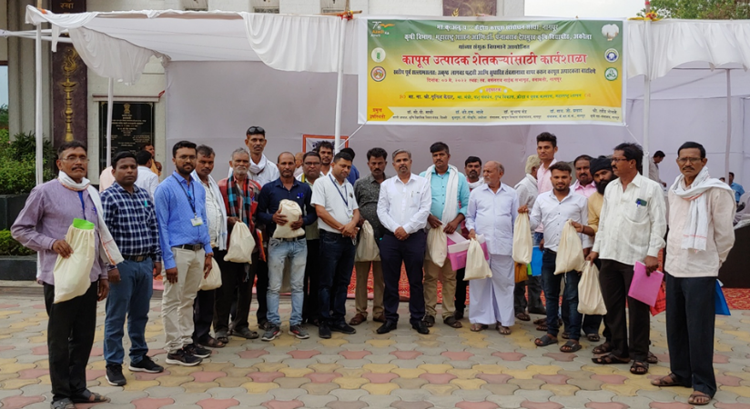
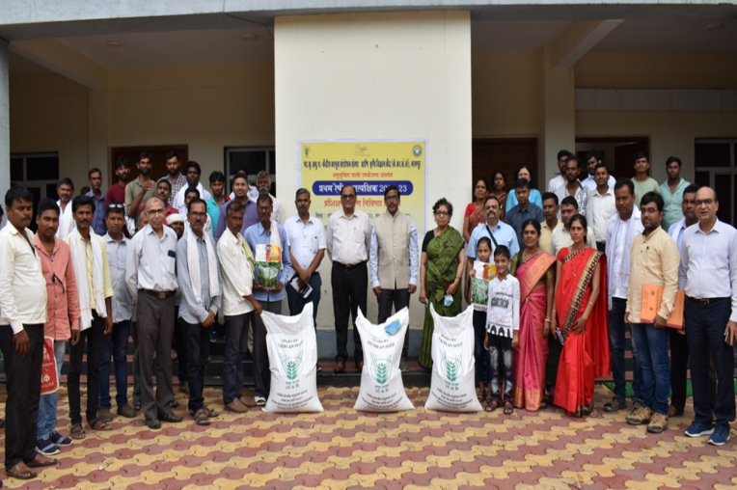
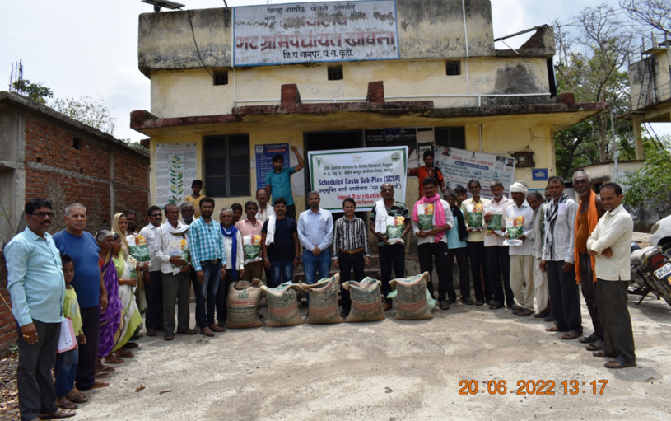
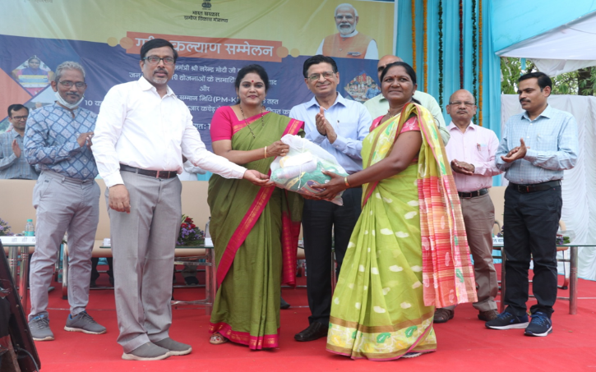
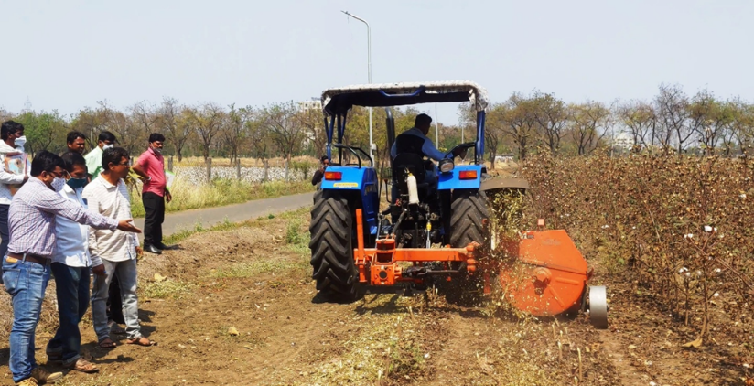
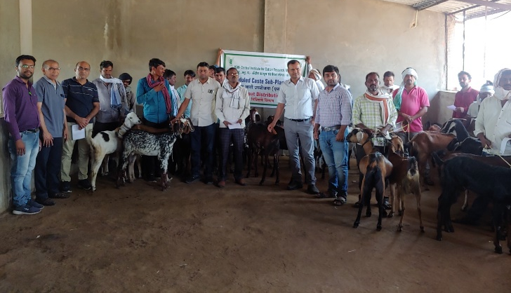
Soybean seed distribution to SC farmers at ICAR-CICR, Nagpur
Tur seed and Paddy seed distribution at. Khobna, Ta. Kuhi, Dist. Nagpur
Stakeholders Interface Farmers Meeting for Pre-Kharif season at Vasantrao Naik State Agriculture Extension Management Training Institute, Nagpur. (VANAMATI)
Input distribution on the occasion of Garib Kalyan Sammelan at. ICAR-CICR, Nagpur

Goat distribution to SC beneficiary at Punyashlok Ahilyadevi Maharashtra Mendhi va Sheli Vikas Prakshetra, Bondri, Ta. Ramtek, Dist. Nagpur

Live demonstration of Cotton Stalk Shredder to SC farmers on cotton field at ICAR- CICR, Nagpur

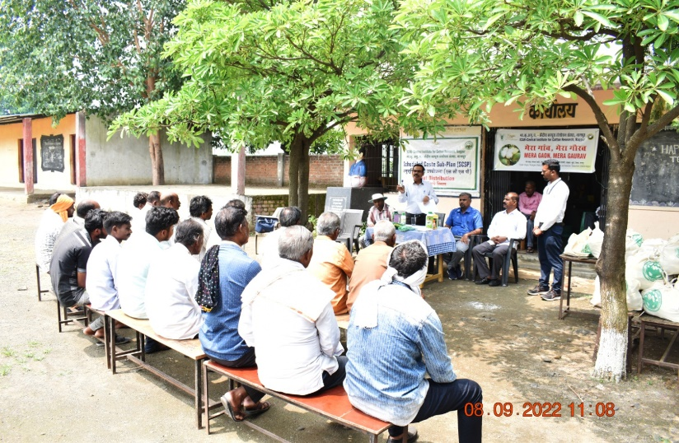
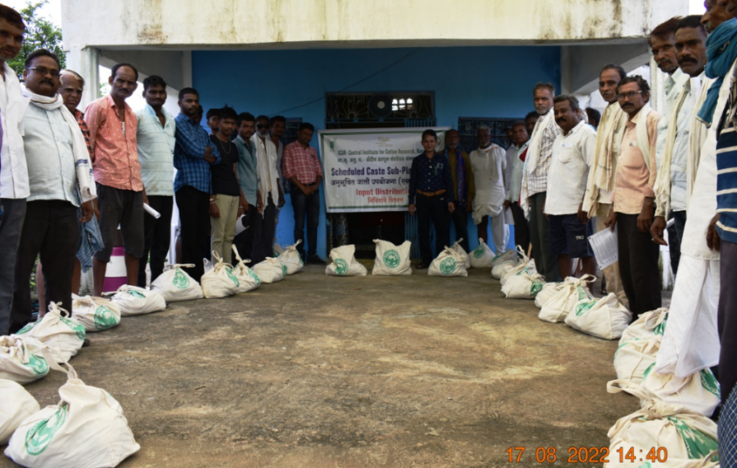

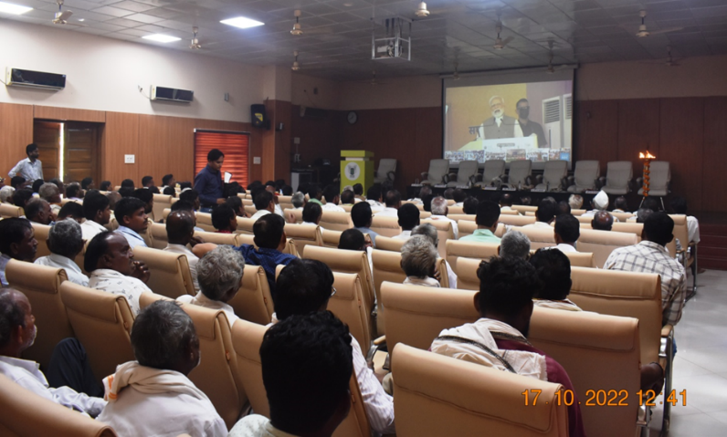
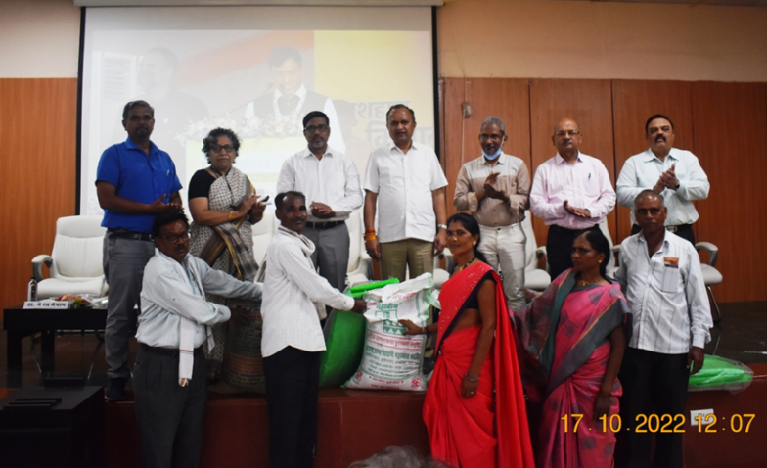
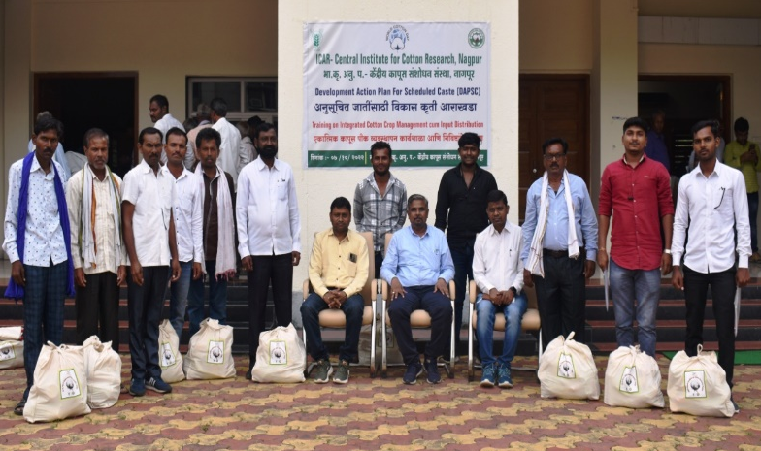
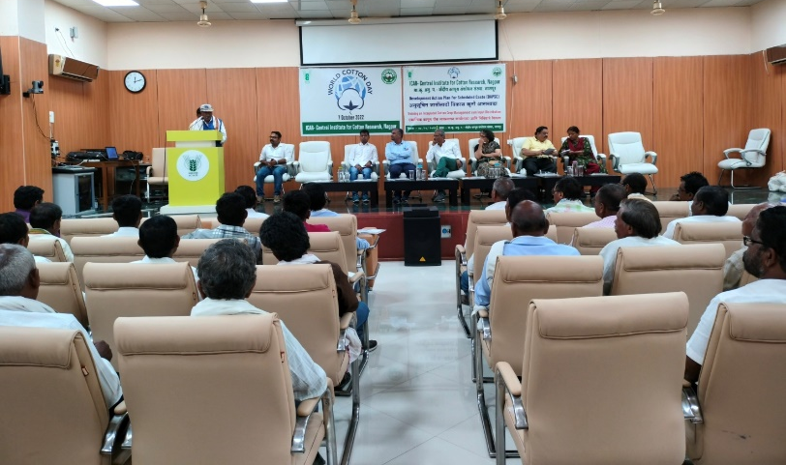
Hon. Prime Minister, Govt. of India addressing farmers through the video conferencing on the occasion of PM kisan Samman Sammelan.

Farmer share experience with other farmers on the occasion of world cotton day
Input distribution on the occasion of World Cotton Day at ICAR-CICR, Nagpur

Training on Integrated Pest Management at. Dongargaon, Ta. Kuhi, Dist. Nagpur
PUSA bio-fertilizers kit distribution at. Pipardol, Ta. Umred, Dist. Nagpur

Input distribution on the occasion of PM kisan Samman Sammelan.

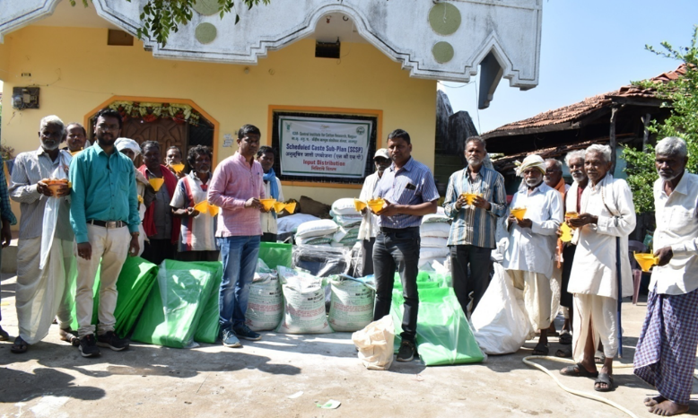
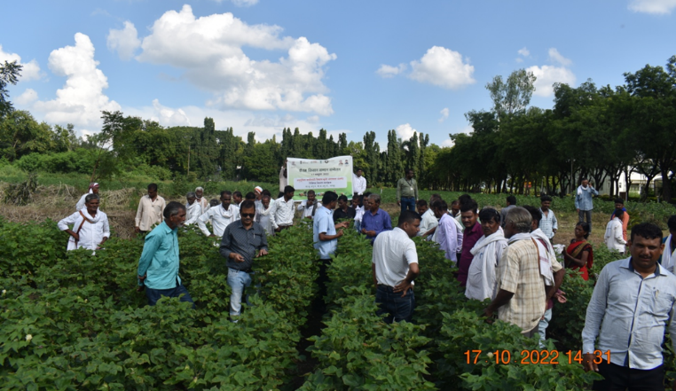
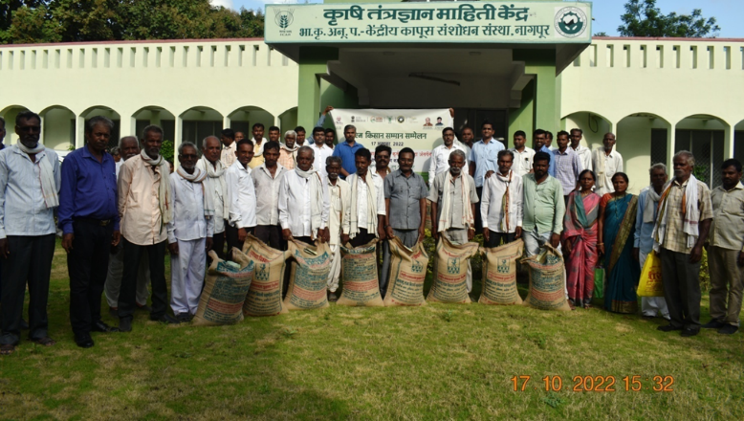
Wheat seed distribution at ICAR-CICR, Nagpur under SCSP

Farmers field visit on the occasion of PM kisan Samman Sammelan at ICAR-CICR, Nagpur

Pheromone trap & PBW Lure, Vermicompost bed and Gram seed distribution at. Pipardol, Ta. Umred, Dist. Nagpur

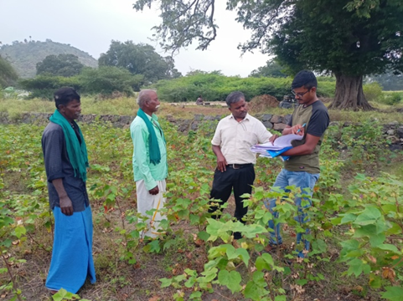
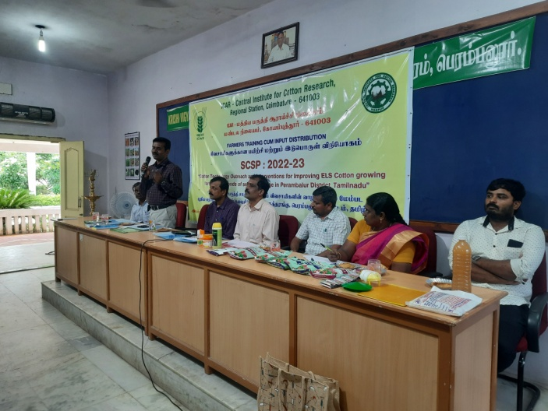
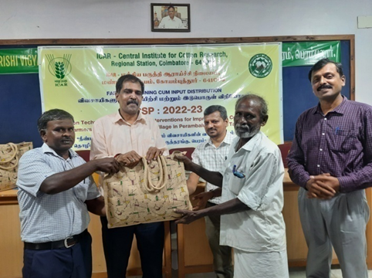
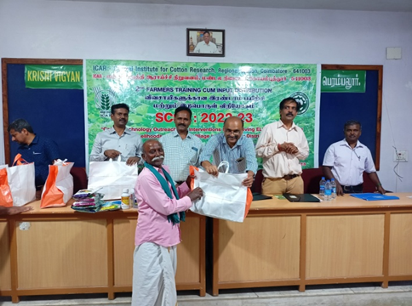
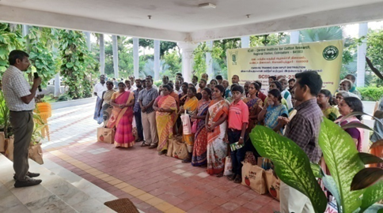

Training on “Cotton technology outreach and interventions for improving ELS cotton” at ICAR- KVK, Hans Roever campus, Valikandapuram, Perambalur, 621115, Tamil Nadu.

